Course Name: | Elements of Electrical and Electronics Engineering | Semester: | I/II
Date of Performance: | 28/12/21 | Batch No: | A2
Faculty Name: | Maruti Zalte | Roll No: | 16010121045
Faculty Sign & Date: |  | Grade/Marks: | / 25

Experiment No: 10

Title: Inverting and Non-inverting amplifier using OPAMP

Aim and Objective of the Experiment:
- To understand the open loop configuration of OPAMP
- To understand the concept of negative feedback and closed loop configuration of OPAMP.
- To understand inverting and Non-inverting amplifier of OPAMP
- To find gain of inverting and non-inverting amplifiers

COs to be achieved:
CO5: Understand operational amplifier and its applications

Circuit Diagram/ Block Diagram:
Pin diagram of IC 741

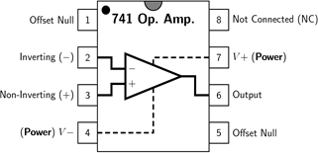

1. Inverting Amplifier
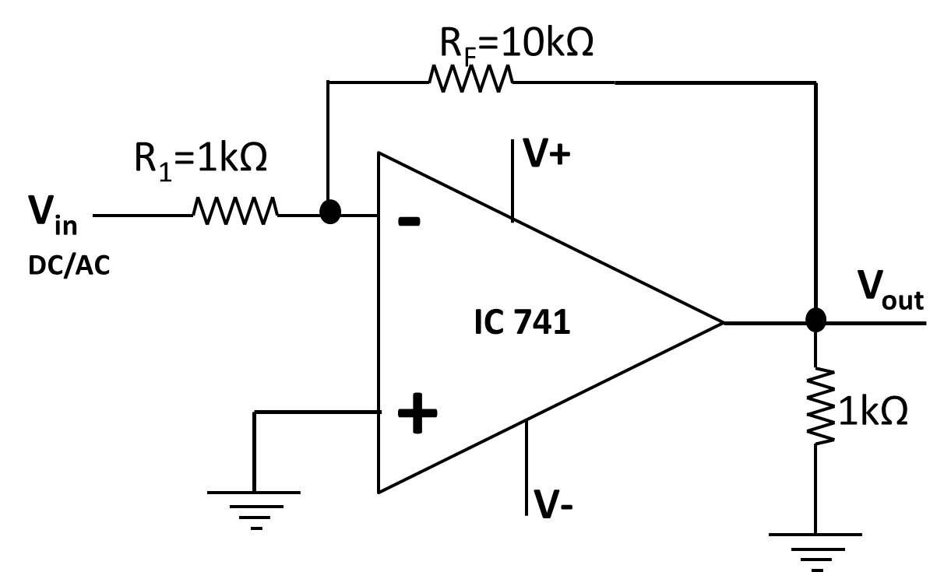

2. Non-inverting Amplifier
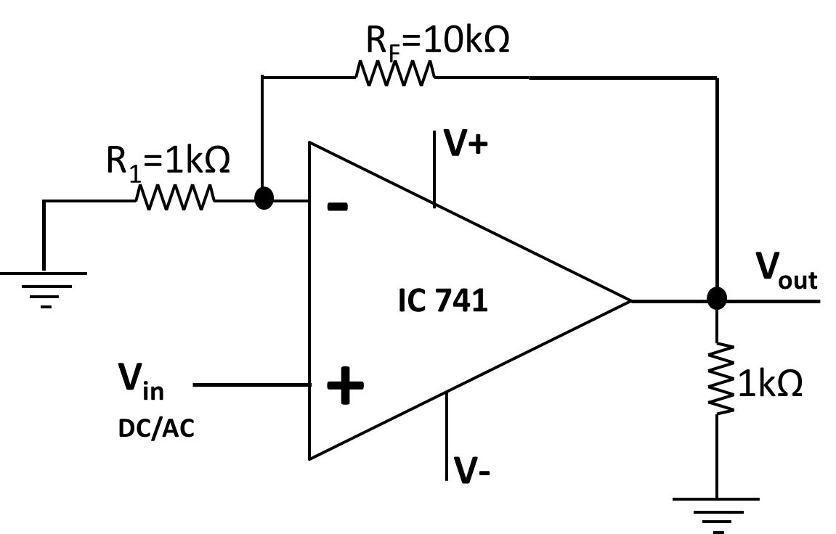

Observation Table:
1. A. Inverting Amplifier: DC input Voltage
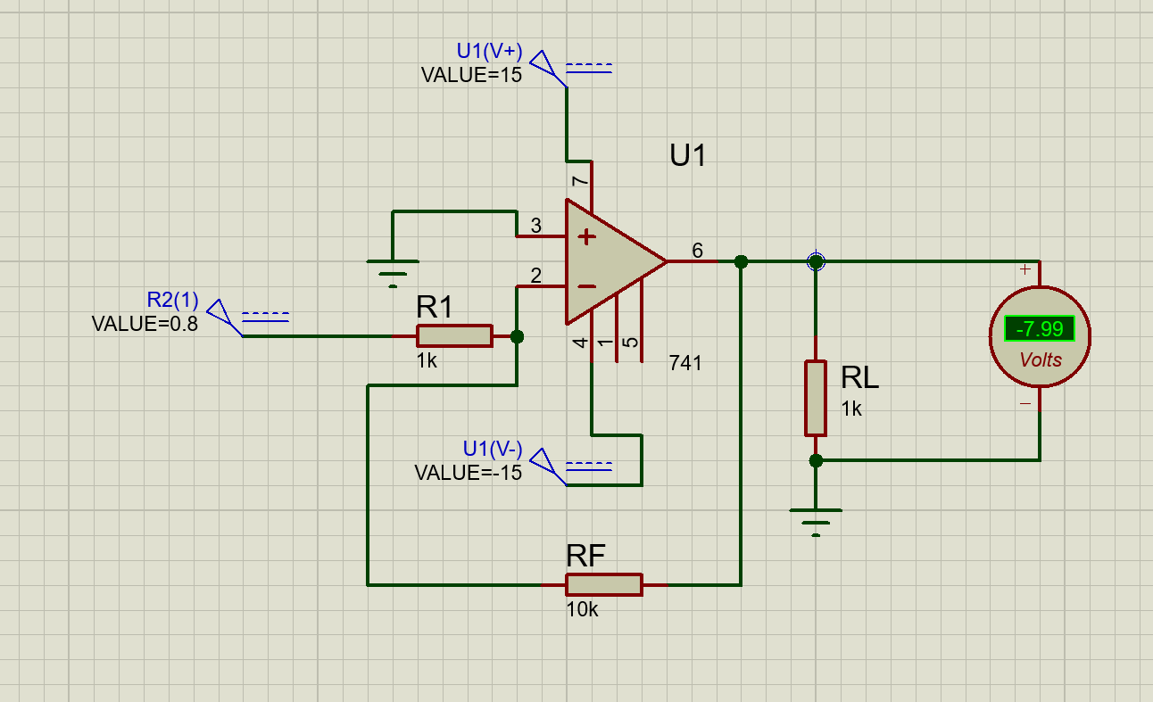

Sr.No. | Vin (V) | Vout (V) | Practical  Gain = Vout/Vin | Theoretical  Gain=-RF/R1
1. | 1 | -9.99 | -9.99 | -10
2. | 1.2 | -12.0 | -10 | -10
3. | 0.8 | -7.99 | -9.99 | -10

1. B. Inverting Amplifier: AC input Voltage
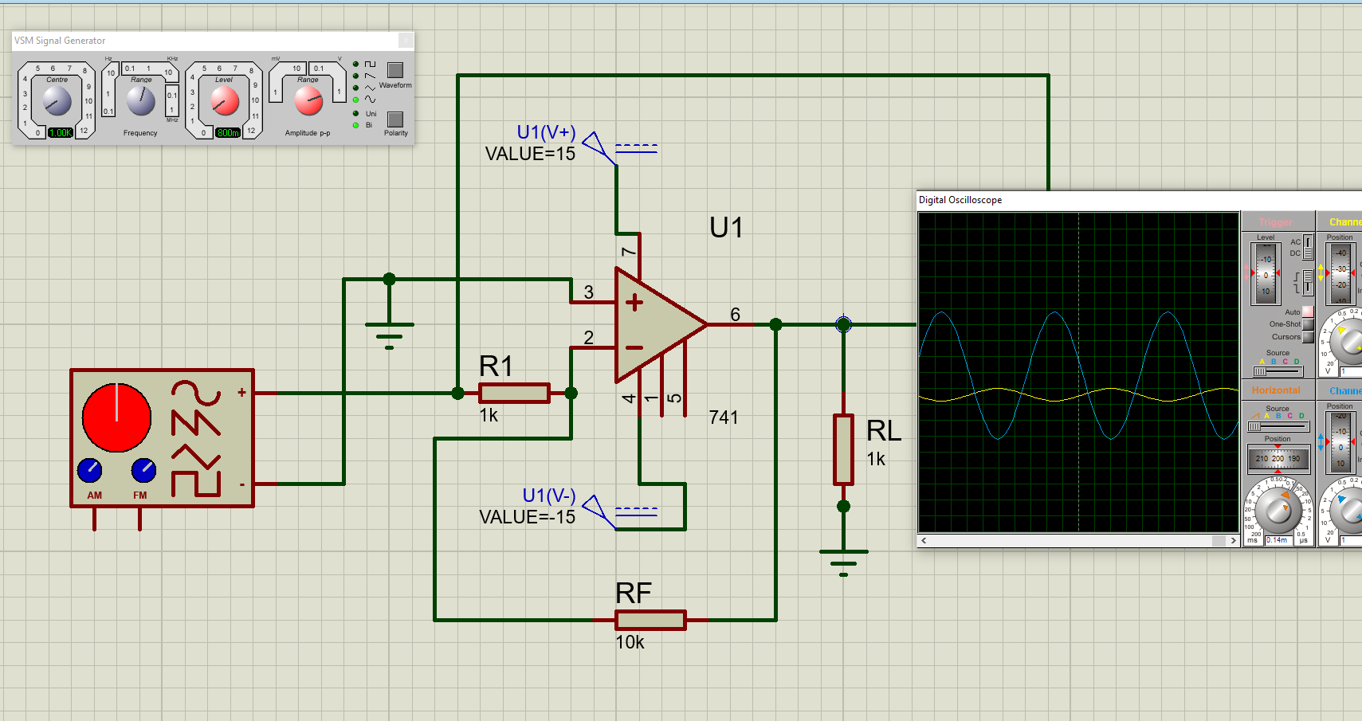
Sr.No. | Frequency (Hz) | Vin(p-p) (V) | Vout(p-p) (V) | Practical  Gain = Vout/Vin | Theoretical  Gain=-RF/R1
1. | 1k | 1 | 10 | -10 | -10
2. | 2k | 2 | 20 | -10 | -10
3. | 1k | 0.8 | 8 | -10 | -10
2. A. Non-inverting Amplifier: DC input Voltage
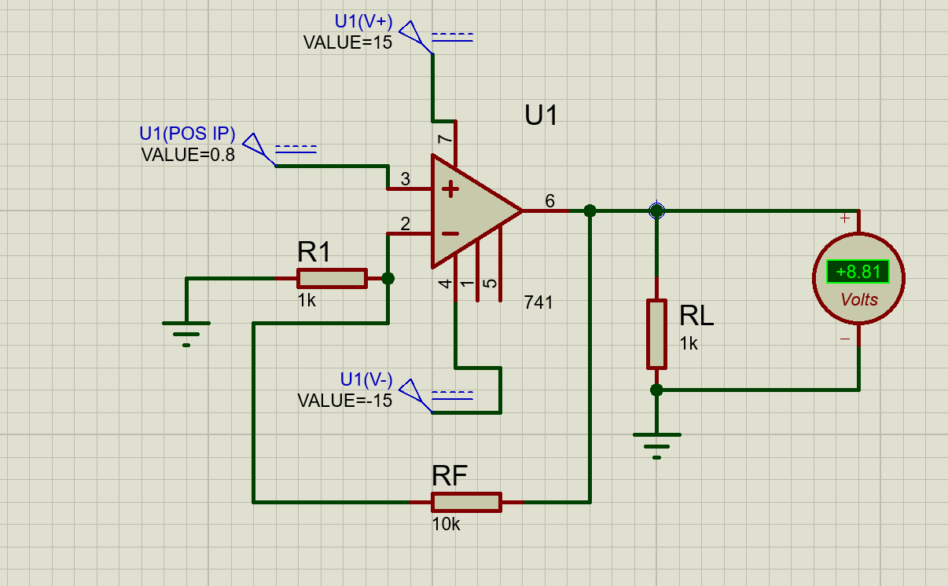

Sr.No. | Vin (V) | Vout (V) | Practical  Gain = Vout/Vin | Theoretical  Gain=1+RF/R1
1. | 1 | 11 | 11 | 11
2. | 1.2 | 13.2 | 11 | 11
3. | 0.8 | 8.81 | 11 | 11

2. B. Non-inverting Amplifier: AC input Voltage
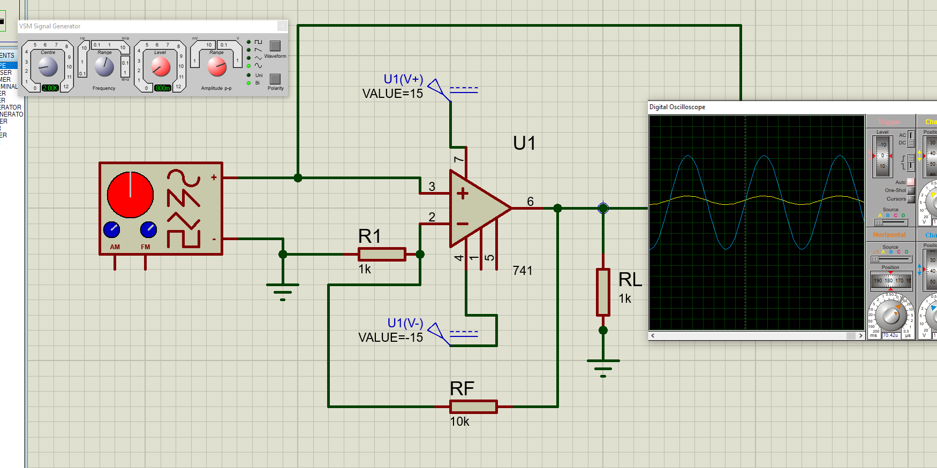
Sr.No. | Frequency (Hz) | Vin(p-p) (V) | Vout(p-p) (V) | Practical  Gain = Vout/Vin | Theoretical  Gain=1+RF/R1
1. | 1k | 1 | 11 | 11 | 11
2. | 2k | 2 | 22 | 11 | 11
3. | 1k | 0.8 | 9 | 11.25 | 11

Post Lab Subjective/Objective type Questions:
1. List the characteristics of Ideal operational amplifier.
- Infinite open loop gain
- Infinite input impedance
- Zero Output impedance
- Infinite bandwidth
- Zero Offset Voltage
- Zero Input Bias current

2. List the important parameters of IC 741 operational amplifier.
- The open loop gain is equal to 2x105
- The input impedance is equal to 2 MOhm
- Output impedance is from 75 - 100 Ohms
- Finite Bandwidth around 1 MHz
- The offset voltage is in the range of 2 - 6 mVolts
- Input bias current is in the range of 500 nAmps

Conclusion:
Open loop, closed loop and the inverting & non-inverting configuration of Op-Amp has been
successfully completed.

Signature of faculty in-charge with Date:

